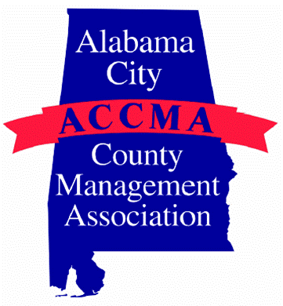
ALABAMA CITY/COUNTY

MANAGEMENT ASSOCIATION

August 1, 2017

ACCMA ANNUAL MEMBERSHIP DUES
Form for 2017-2018 Membership Year
(October 1, 2017 – September 30, 2018)

Organization Name:_______________________________ Telephone:_________________

Address:_______________________________ Web Address:________________________

The ACCMA would like to invite you and others in your organization to become a member and enjoy the many benefits available through the association including discounted registration for each of the two annual educational events. Eligible members include City and County Managers, Administrators, Assistant Managers, Assistant Administrators, Clerks, Finance Directors, Accounting Clerks, Personnel Directors, Mayors, Council Members, Chairpersons, Commissioners, other administrative & assistant administrative personnel, MPA students and professors from Alabama’s colleges and universities, and Businesses in good standing with the Association whose products or services do not compete with the Alabama League of Municipalities or the Association of County Commissions of Alabama. Membership in ACCMA for 2016-2017 is due October 1, 2016. Direct any questions regarding ACCMA membership to Julia Heflin at 334-844-4782 or heflijb@auburn.edu.

(Please list all persons joining membership)

Name:_____________________ Title: ____________________ Email:_________________________________

Name:_____________________ Title: ____________________ Email:_________________________________

Name:_____________________ Title: ____________________ Email:_________________________________

Name:_____________________ Title: ____________________ Email:_________________________________

Name:_____________________ Title: ____________________ Email:_________________________________

Name:_____________________ Title: ____________________ Email:_________________________________

Name:_____________________ Title: ____________________ Email:_________________________________

Name:_____________________ Title: ____________________ Email:_________________________________

Total Amount Enclosed: $__________ $75 City/County Regular Member p/person;
$50 Associate Member p/person;
$10 Student Member p/person;
$150 Business Member p/business

DUE OCTOBER 1, 2017!

EXPEDITE YOUR MEMBERSHIP BY FAXING FORM TO: 334-844-1919
Payment online with credit card at www.accma-online.org
Make checks payable to: ACCMA
Mail to: ACCMA, C/O GEDI, 22 Extension Hall, Auburn AL 36849.

